BISWAS, PRIYANKA

4/3/2016

Prototype Report

Team 18

KAKARLA MATHAM, DINESH

LANKALA, SAGAR CHANDRA REDDY

NARRA, dILEEP REDDY

NEELAGIRI, NITISH

**ISYS 631 603**

MAYS BUSINESS SCHOOL, TEXAS A&M UNIVERSITY

**Contents**

**Screens Developed** 2

Home page 2

Login page 3

Registration page 5

**Functionality** 6

**Hosting** 6

**Tables Used** 6

Patient 6

Login 6

**Entity Framework** 6

MVC Architecture 6

Model 6

View 7

Controller 7

**Design Elements Implemented** 7

Golden ratio 7

Baby-face bias 7

Looking Room 7

**Color Palette** 7

Blue 7

Yellow 7

White 7

**Design Persona** 8

**Responsiveness Strategy** 8

Media Query 8

# **Screens Developed**

## Home page

The home page of the “Joaquina Dental Clinic” is the first page that user lands on. We have tried to incorporate several elements like: happy and smiling faces, a friendly mascot, registration link, and recommendations etc. to offer a welcoming and warm experience for our present and prospective clients.

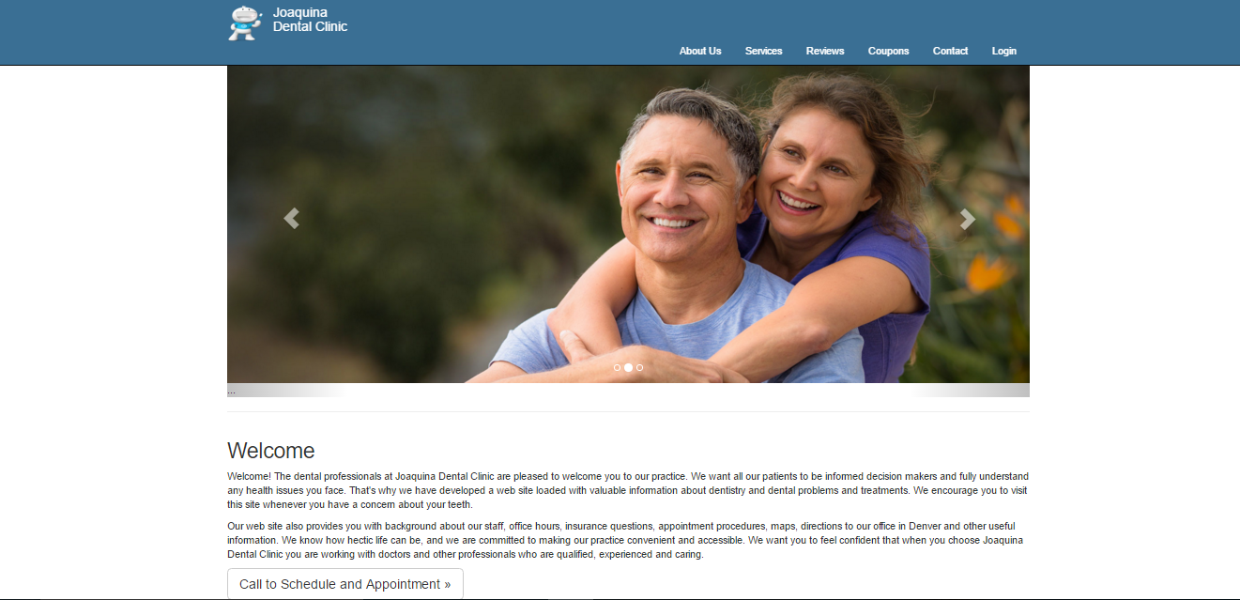

*Home Page on the desktop platform*

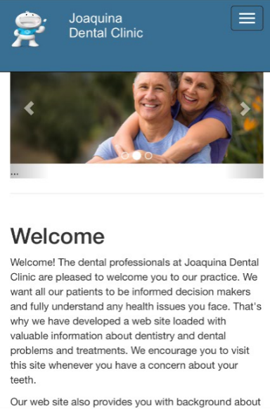

*Home Page on the Phone platform*

## Login page

We have implemented a very simple Login page without much clutter. An existing client can visit this page and enter their credentials to navigate to their personalized information page.

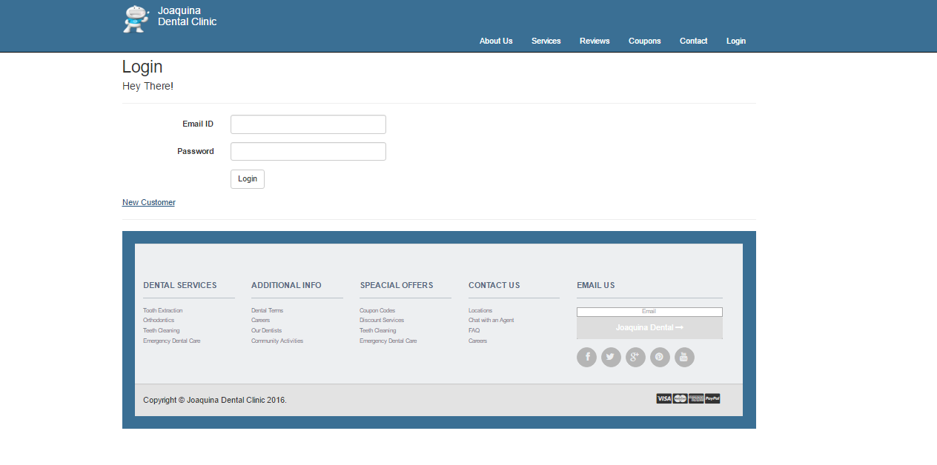

*Login Page on the desktop platform*

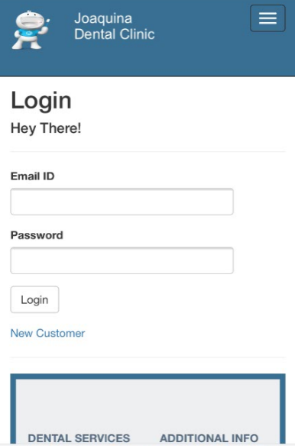

*Login Page on the phone platform*

## Registration page

A new customer can use the “Register Now” button either from the Home page or the Login page to register to our dental services. A welcoming experience has been introduced by means of welcome messages on the page.

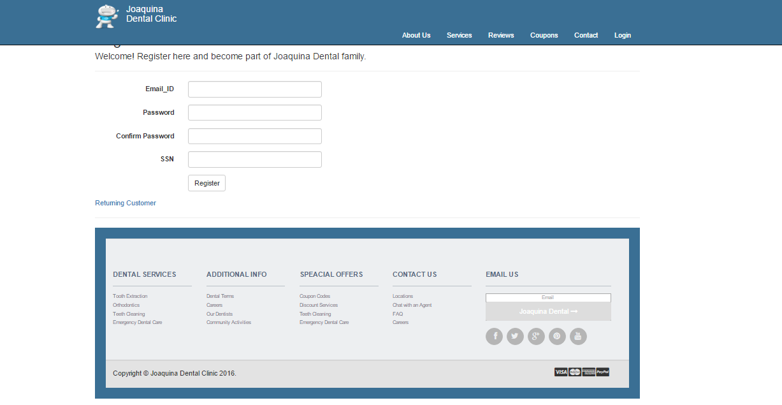

*Registration Page on the desktop platform*

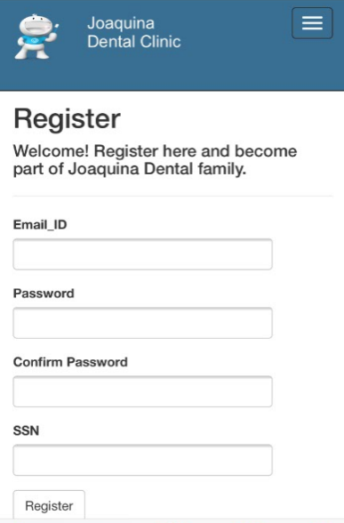

*Registration Page on the Phone platform*

# **Functionality**

All the three pages described above have been designed to be displayed on multiple platforms namely: phone, tablet and desktop.

# **Hosting**

We have used Microsoft Azure for hosting our website.

**Link to the application:** <http://joaquinadental18.azurewebsites.net/>

Below are the account details to test the application.

**Username:** a.b@c.com

**Password:** qwer

# **Tables Used**

## Patient

The Patient holds the information of existing patients. It would be used for displaying the patients' details after a particular patient logs in.

## Login

Currently the application is designed in such a way that while registration, only existing patients in the given database would be able to register through the application. The login information of the particular user would be stored in login table on successful registration.

# **Entity Framework**

We have used the MVC architecture to implement our Entity Framework and work with the relational data.

## MVC Architecture

The MVC architecture separates the application into three logical components as follows:

### Model

This component corresponds to all data related logic like the data that is being transferred between the View and Controller components or any other business logic related data.

### View

This component supports the UI logic of the application.

### Controller

This component acts as an interface between Model and View components to process all the business logic, data manipulation using Model and final output rendering using View.

# **Design Elements Implemented**

## Golden ratio

Two aside tags have been used two achieve a golden ratio (1.618:1) in the Home page.

## Baby-face bias

The baby-face bias has been implemented in the website logo/mascot “Mr. Toothy”.

## Looking Room

The concept of looking room has been effectively used in the image slideshow of the home page to direct user’s attention to the “Register Now” button.

# **Color Palette**

We have employed Blue, Yellow and White as the main colors in designing our website.

## Blue

Blue color signifies calmness, trust and coolness. We have used this color to incite a feeling of trust and dependability in our clients.

## Yellow

Yellow signifies joy, happiness and positivity. We have used this color to represent a positive and welcoming image of our website.

## White

White signifies purity, righteousness and light. We have used this color to symbolize our vision and transparency of our services.

# **Design Persona**

“Mr. Toothy”, the mascot of our dental clinic is extremely warm and witty. He welcomes the clients with a happy welcome message and stays with them throughout the process of scheduling an appointment with occasional remarks filled with wit and humor.

# **Responsiveness Strategy**

## Media Query

We have used “Media Queries” to achieve responsiveness in our website design. It uses @media rule to include a block of properties only if a certain condition is true.